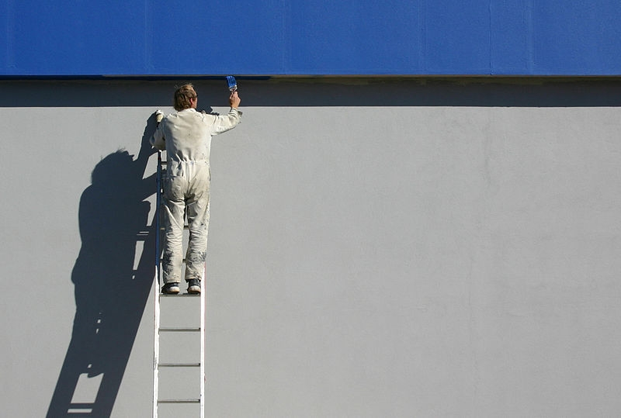

Overpeck Painting

Jamie Overpeck ~ Owner

(662) 549-7465

info@Overpeck.biz

* Plaster and drywall repair
* Painting
* Power-washing
* Licensed
* Insured
* Residential
* Commercial